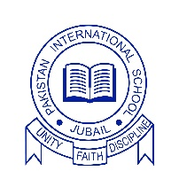
Pakistan International School, Jubail

Date: 12 March 2026

Dear Members of the Community,

Assalam O Alaikum,

Subject: Admissions open for the New Academic Year 2026-2027

We are pleased to announce that Pakistan International School Jubail is now accepting applications for new admission for the Academic Year 2026-2027 from Grade KG to 12. We extend a warm invitation to the families who are interested in enrolling their children in the school for new session.
Our school is committed to providing a nurturing and academically rigorous environment where each student is given the opportunity to grow intellectually, socially, and emotionally. The dedicated faculty has kept on striving to foster a love for learning and a sense of responsibility in our students through curricular and extra-curricular activities.

Admission Details:
- Admission Open From: 28 March 2026
- Admission Close On: 1 April 2026
- Timings For Admission Test: 8:00 AM to 12:00 PM
- Application Forms: Available at the school office or on our website www.pisjubail.edu.sa
- Contact Information: For inquiries, please contact our admission office at 13-3621110 or admissions@pisjubail.edu.sa

We encourage all interested families to visit the school and meet with our administration team. Our staff will be happy to answer any questions you may have and provide you with more information about the programs and opportunities available for your child.
Please note that seats are limited and follow the above-mentioned dates for admission. Admission is subjected to the availability of the seat for the applied grade.

We look forward to welcoming new students into our school community and working together to create a bright future for them.

Warm regards,
Dilshad Khan
Principal (A)

